Pankaj Sharma 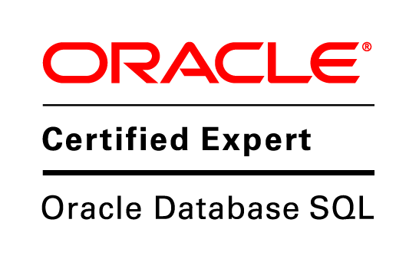

#131/20, Indira Colony, Cell: 9953819377
Sonepat, Haryana. Home: 8950814803
E-mail: pankaj.attri22@gmail.com

Career Objective

Seeking a challenging position in the area of Oracle Application Development/ Pl Sql Development and achieve company's goals. To utilize my skills and abilities in an organization that offers professional growth while being resourceful, innovative and flexible.

Profile Summary

I am an Oracle Certified Associate in oracle 10g, having strong knowledge of Sql and Pl/Sql.

1 year of experience in Oracle Forms/Pl Sql Development.

Dynamic 2.2 years of experience in Data Processing. Around 1 year of experience in Project Management.

Professional Experience

Bakshi Mark Pvt. Ltd. May, 2015 – Present

Bakshi Mark Pvt. Ltd (Erstwhile Bakshi Enterprises) is India`s most preferred and trusted name in the business of Marking, Coding, Traceability and Conveying. We also provide services like Coding Consulting, Contract Coding, Turnkey Projects Undertaking & Post Sales Support to our customers.

I am working as a Senior Programmer in my team and handling following key Responsibilities:
- Web Application Design and Development using Oracle Forms.
- Writing stored procedures, triggers and functions.
- Query optimization and performance tuning. Unit testing and peer code review as well.
- Getting exposure to complex query writing and performance tuning.
- Learning how to build initial test cases and code review processes.

Weblink .In Pvt. Ltd. May, 2014 – April, 2015

Weblink India is a leading web design company, we are providing all type of web design and Website Development solutions to thousands of clients for over a decade. Our affordable web design services Includes Everything You'll Need to Get Started with Stunning Results.

I worked as a Project Coordinator in my team and handled following key Responsibilities:
- Project management from start till successful completion.
- Understand client’s requirement for project.
- Assign project work to development/design teams.
- Project delivery and coordination with client.
- Ensure quality through website testing.

AbsolutData, Research and Analytics March, 2010 – June, 2012

AbsolutData Research & Analytics provides consulting-oriented Advanced Analytics and Market Research services to organizations globally, helping them make a definitive difference to their performance. Our offerings can be categorized under 3 broad heads as:
- market research – full service modular
- advanced marketing analytics
- online data collection services

I worked as a Programmer in my team and handled the following key Responsibilities:
- SPOC of a tabbing team.
- Understand client’s requirement for the project
- Application of multiple statistical techniques to extract important insights from data as per the client needs.
- Data retrieval and Report Generation. It also includes
  - Tabulation
  - Weighting
  - Data Validation

Key Projects

Currently working on an in house ERP for company.
Assigned Modules:
- Production planning and control
- Manufacturing.
- Inventory Management
- Sales and finance.

Bakshi Mark pvt ltd.
The salient features in the module involve the following transactions:
- Purchase Requisition and Purchase Order.
- Inward Raw Material and Finished Goods Inspection.

Opinion Research Corporation

Led team of 3 members: the team was responsible for providing the tabulated data, comparison of the trended data to the client at a regular interval.

Point of contact with the client; provided suggestions which were appreciated by the client.

Start a Dialogue

This was a wave study; need good skills in quantum as well as SPSS. Received recognition for the excellent quality of the tabs.

Got many new projects on the basis of performance of this project.

Awards and Achievements

Received “Absolut Oscar” award for Process Excellence, by AbsolutData, Research and Analytics.

Received “Absolut Oscar” award for Best Buddy, by AbsolutData, Research and Analytics for training and assisting new joinees.

Received “Star of the Month” award, by AbsolutData, Research and Analytics, in recognition of outstanding work done on project and client appreciation received.

Academic Qualifications

Professional:-

Bachelor of Technology
B. Tech. in Computer Science & Engg. from Kurukshetra University.

Master of Technology
M. Tech. in Computer Science & Engg. from Deenbandhu Chhotu Ram University of science & technology, Haryana.

Academics:-

DEGREE/COURSE | Board/University | PASSING YEAR | PERCENTAGE
M.Tech. | DCRUST, Haryana | 2014 | 6.92 CGPA
B.Tech. | K.U., Kurukshetra | 2009 | 67%
12th | B.S.E.H., Haryana | 2005 | 54.6%
10th | B.S.E.H., Haryana | 2002 | 77%

Technical Skills

Basics : Presentation Fundamentals & MS-Office.

Operating System : Windows.

Statistical Tools : Quantum, Spss.

Programming Language : Pl/sql.

Database : Oracle 10g.

Personal Dossier

Date of Birth : 22-01-1987

Father’s Name : Sh. Jagdish Sharma

Language Proficiency : Hindi & English

DECLARATION

I assure you; if given a chance I will put my best efforts, hard work and sincerity in my work.
I hereby declare that the above written particulars are true to the best of my knowledge and belief.

Pankaj Sharma

